Analysis of the excited energy-states of cis-β-Apo-8’-carotenal using
time-resolved absorption spectroscopy

Kota Horiuchi¹, Chiasa Uragami¹, Taiki Inoue¹, Nao Yukihira¹,
and Hideki Hashimoto^{1*}

¹ Department of Applied Chemistry for Environment, School of Science and Technology,

Kwansei Gakuin University, 2-1 Gakuen, Sanda, Hyogo 669-1337, Japan.

1. Introduction
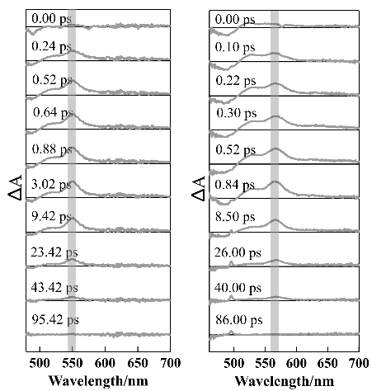
β-Apo-8’-carotenal is one of the carotenoids that has a carbonyl group coupled to its polyene backbone and has nine conjugated C=C double bonds. The light energy that is captured by carotenoids is transferred to chlorophylls in order to initiate photosynthetic light reaction. When carotenoids absorb photons, they are excited up to the second excited singlet state (S₂ state) from the singlet ground state (S₀ state). However, it is recognized that carotenoids with carbonyl group generate the ICT (Intramolecular Charge Transfer) excited state [1]. The ICT excited state is an excited energy-state that is very important to improve the efficiency of excitation energy-transfer from carotenoid to chlorophyll. It is confirmed that all-trans-β-Apo-8’-carotenal (see Figure 1 for its chemical structure) generates the ICT excited state following photoexcitation when it is dissolved in polar organic solvents [1]. In this study, we focused on the ICT excited state of cis-β-Apo-8’-carotenal. We isolated cis-isomers of β-Apo-8’-carotenal that were produced by photoisomerization and applied them femtosecond time-resolved absorption spectroscopic studies.
S₁→S_{N} transition
Figure 1. Chemical structure of all-trans-β-Apo-8’-carotenal
2. Experimental
To obtain cis-isomers of β-Apo-8’-carotenal, we applied photoisomerization of the all-trans isomer using iodine as a catalyst. 13’- and 9-cis isomers were isolated and purified by means of HPLC [2]. We dissolved 13’-cis-β-Apo-8’-carotenal in polar and nonpolar solvents (acetone, methanol, and n-hexane) and 9-cis-β-Apo-8’-carotenal in n-hexane. We recorded femtosecond transient absorption spectra of these cis-isomers.
3. Results and Discussion
We found that the 13’-cis isomer in polar solvent generates the ICT excited state as has similarly been exemplified by the all-trans isomer. In the case of 9-cis-isomer, the steady-state absorption exists at the shorter wavelength region than that of the all-trans isomer. However, as shown in Figure 2, the transient absorption band that represents S₁→S_{N} transition of 9-cis isomer in n-hexane is redshifted compared with that of the all-trans isomer. From this observation, it is suggested that the energy gap between S₂ and S₀ in the 9-cis isomer is larger than that of all-trans, but the gap between S₁ and S_{N} in 9-cis is smaller than all-trans.
Figure 2. Femtosecond time-resolved absorption spectra of all-trans and 9-cis-β-Apo-8’-carotenal in n-hexane at room temperature

[1] M. Durchan, M. Fuciman, V. Slouf, G. Kesan, T. Polivka, J. Phys. Chem. A, 116 (2012) 12330-12338.
[2] H. Hashimoto, Y. Miki, M. Kuki, T. Shimamura, H. Utsumi, Y. Koyama, J. Am. Chem. Soc. 1993, 115, 9216−9225.

